Poke Bowl

|  |
| --- |
| Ingredients With Measurements  * 1 lb. sushi-grade ahi tuna * 2 tablespoon soy sauce * 1 tablespoon sesame oil * 1 tablespoon rice vinegar * 1 teaspoon honey * ¼ cup light mayo * 1 teaspoon sriracha * 4 cups cooked brown rice * 1 cup diced cucumber * ½ cup shredded carrots * ½ cup shelled edamame * 2 large avocados, peeled and sliced * 1 tablespoon black sesame seeds * 1 teaspoon green onion |

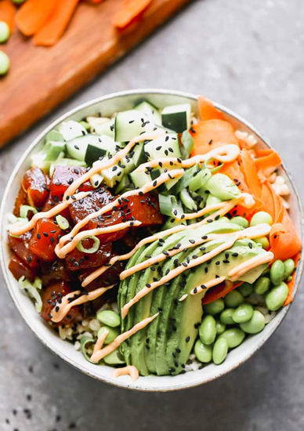

|  |
| --- |
| Recipe Use a sharp knife to cut tuna into a dice. Add tuna, soy sauce, sesame oil, rice vinegar, and honey to a medium bowl. Toss to combine. Let the tuna sit while you prepare the rest of the ingredients.  Add mayo and sriracha to a bowl. Stir to combine. Season with salt and pepper. Spoon into a Ziplock bag. Cut the tip off.  Divide cooked rice between four bowls. Spoon tuna on one part of the rice. Surround with a pile of the cucumber, edamame, and carrot. Spread half of an avocado on top of the bowl. Drizzle the spicy mayo over the bowl. Sprinkle with green onion and sesame seeds. |

|  |  |  |  |  |  |  |  |  |  |  |  |  |  |  |
| --- | --- | --- | --- | --- | --- | --- | --- | --- | --- | --- | --- | --- | --- | --- |
| |  |  | | --- | --- | | Ahi Tuna | Soy Sauce | | Sesame Oil | Rice Vinegar | | Honey | Light Mayo | | Sriracha | Brown Rice | | Cucumber | Carrots | | Edamame | Avocado | | Sesame Seeds | Green Onion |  Ingredients Without Measurements |